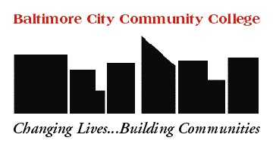

Baltimore City Community College
Disability Support Services Center
Main 023
410-462-8585 (PH) 410-462-8584 (TTY)

Grievance and Appeal Form

Please complete and return to Disability Support Services Center.

Name: _______________________________________ Student ID#:____________________________

Address: ____________________________________________________________________________

City: ________________________________________ State: _________ Zip: _______________

Phone: ______________________________________ Cell Phone: _____________________________

E-Mail: ______________________________________________________________________________

In accordance with Title II of the ADA which prohibits discrimination based on disability by any public entity, including colleges, and Section 504 of the Rehabilitation Act which prohibits discrimination based on disability by recipients of federal financial assistance, DSSC and BCCC will to attempt to resolve internally all types of grievances at the level where they occur and in a timely manner.
Please give a statement of the written law, rule, policy, and/or procedure violated:
____________________________________________________________________________________________________________________________________________________________________________________________________________________________________________________________________________________________________________________________________________
Please state the resolution or remedy you want:
____________________________________________________________________________________________________________________________________________________________________________________________________________________________________________________________________________________________________________________________________________

_________________________________________________________________________________
Student Signature Date Submitted to DSSC Coordinator

